2025
The Parish Church of the Ascension, Hall Green
CHARITY NUMBER 1133810

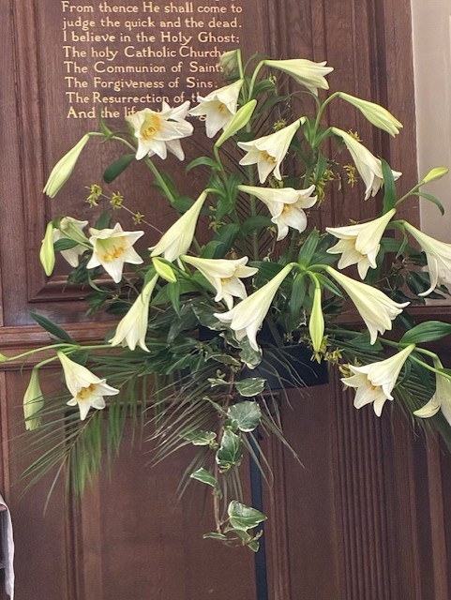
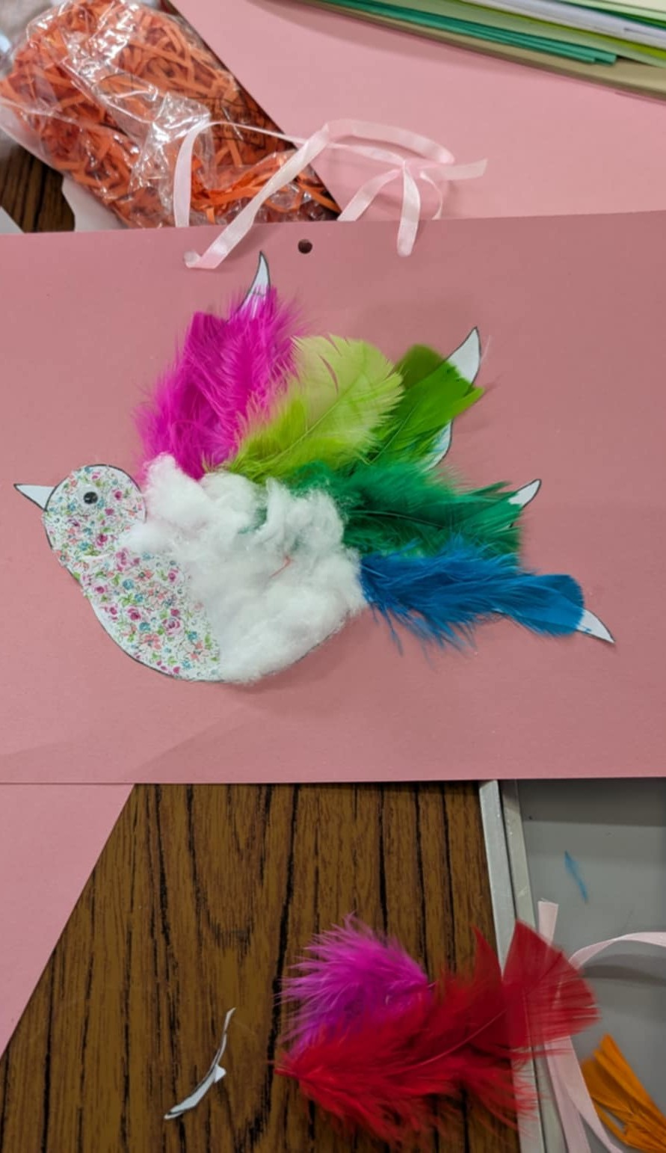
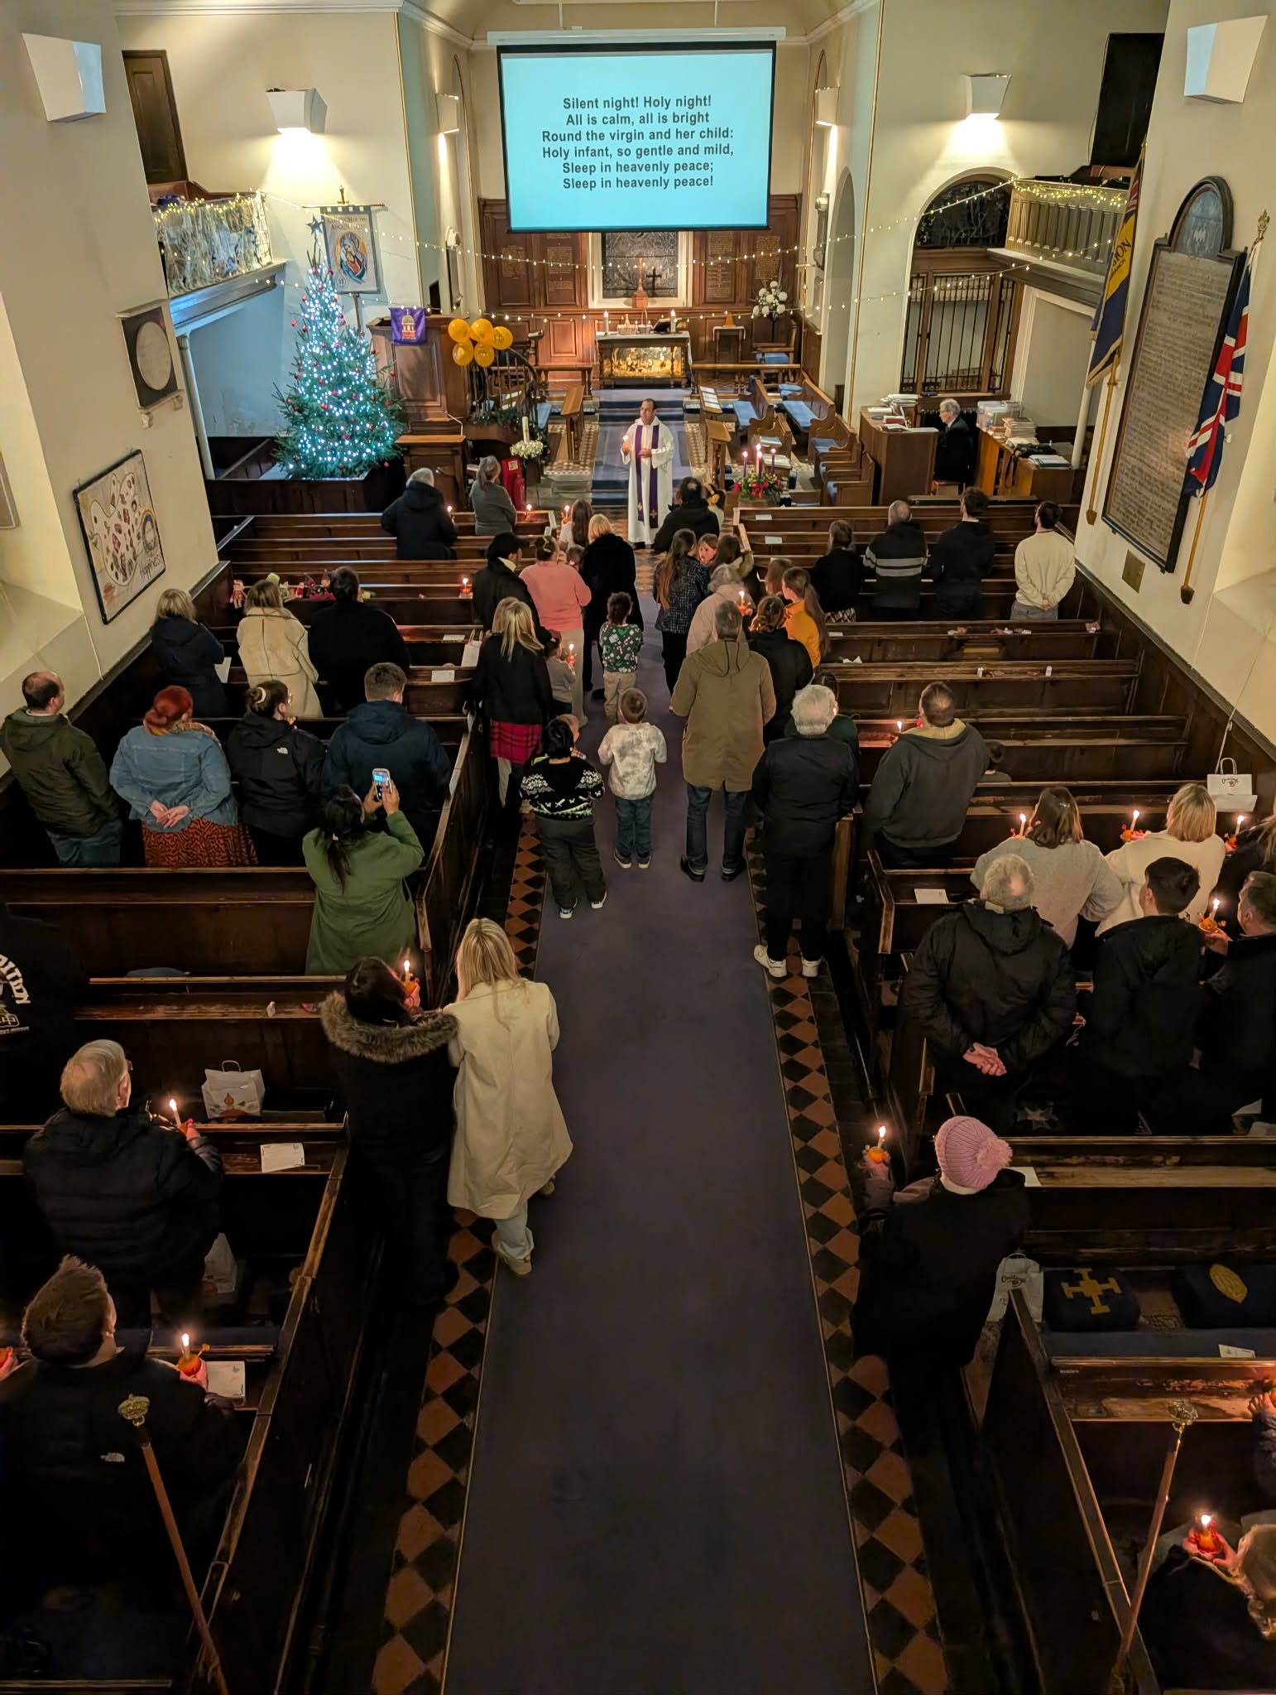
Annual Report
Annual Report of the Parochial Church Council of the Ascension, Hall Green

Aim and Purposes
The Parochial Church Council (PCC) along with the vicar, Revd. Canon Nejib Boumenjel, share the responsibility of promoting the mission of the church: pastoral, evangelistic, social, and ecumenical in the parish of The Ascension, Hall Green.

Objectives
Our site brings people together for Christian worship, education and fellowship as well as providing multiple opportunities for service to the wider community. Anyone is welcome to worship here and to become part of our parish community.

Our Vision:

At The Church of The Ascension, we seek to be a friendly and welcoming church with a passion for loving service to the local community where people of all ages can experience the love of God, grow in faith and receive the spiritual and pastoral support they need.

Our Mission Statement:

The Church of The Ascension exists to love God, love People and to make disciples of Jesus who will make a difference in our community and beyond.
When planning our activities, we have considered the Charity Commission’s guidance on public benefit and supplementary guidance on charities for the advancement of religion. We try to enable people to live out their faith as part of our Christian community through:
- Worship, prayer, and education in the gospel.
- Provision of community spaces.
- Mission and outreach work.
- Partnership initiatives with other local charities, church hall users, fellow churches and others.
- Pastoral care for people living in the parish; and
- Stewardship of The Ascension’s physical, financial and human resources.

This Annual Report is the story of the period between our Annual Parish Meetings on 18th May 2025 and 17th May 2026.

Our People

We acknowledge those continuing to give their time and talents in God’s service. We would especially like to thank The Revd. Canon Nejib Boumenjel for his continued and outstanding dedication to God’s service as he leads worship, mission and outreach and gives pastoral care to all who need it.

We thank Pauline Price, our churchwarden, for her dedication and hard work over the past five years. We also acknowledge the vital contributions made by lay readers, our treasurer, PCC Secretary, all those who coordinate and undertake aspects of our mission and outreach work and those who perform important tasks ‘behind the scenes’. We would also like to thank Martine Whitmore, our Parish Administrator, for her continued contribution to the life of our church.

The Electoral Roll was renewed between the dates of 20th April and 2nd May 2025. After the revision, the number of persons on the Roll is 77, down from 83: 12 are resident within the parish boundary – down from 14, and 65 are non-resident – down from 69 last year. One person is on the Roll of two parishes.

The past year has sadly seen the passing of more long-standing members of our Church family, including Eleanor (Irene) Sharp.

Shortly before the publication of this Annual Report, our Director of Music and Vice Chair of the PCC, Clive Jones passed away. Clive made a huge contribution to the worship and mission of the Ascension over more than 50 years, first becoming organist and choir master in 1972. He founded Hall Green Child Contact Centre in 2011 and was chair and driving force of the company thereafter. He served as church warden for 5 years and did an enormous amount of work during that time and afterwards on property matters, including bringing major repairs to the churchyard wall to fruition. Everyone who knew Clive will greatly miss him for his musical gifts, quiet dedication, knowledge, wisdom, enthusiasm and quick wit. May he rest in peace and rise in glory.
Worship and Prayer
Services are held at 8.30am (second and fourth Sundays), 10am and 4pm on Sundays plus a mid-week service at 10.30am on Wednesdays. We also have occasional services at 6pm on Sunday.
A service of Holy Communion continues to be held each Sunday afternoon at 4pm in Arabic.
We would like to thank our small, dedicated choir for their continued contribution to our worship.
We continue to welcome some new worshippers but overall congregations remain smaller than prior to the Covid Pandemic. Our festival services at Christmas and Easter attract larger congregations.
We enable our community to celebrate and thank God at the milestones of their journey through life. Through baptism we thank God for the gift of life and we were encouraged to have a number of baptisms in 2025. Funeral services allow friends and family to express their grief and give thanks for the life now complete, commending the person into God's keeping. We also hold twice yearly Services of Thanksgiving and Remembrance for those we love who have died. These are important as a public way to remember loved ones, and an expression of pastoral care, as we keep in contact with those who have lost loved ones.
On 29th June 2025, we had a service to mark Volunteering Sunday, giving thanks for the many volunteers whose work is essential to the mission and ministry of our church.
There are fortnightly Monday prayer meetings where we share and pray for those things for which we would like to seek God’s guidance, as well as things for which we would like to give thanks. Bible Study also takes place on alternate Mondays. A Home Group is also held on Tuesday evenings in Arabic.
Sunday School operates at the 10am service on 3 Sundays a month (apart from August, Bank Holidays and major festivals). We have 8 children between the ages of 3 and 11 attending our Sunday School. We give thanks for these children and for this opportunity to help them to grow in faith.
Messy Church continues to be an important ministry, based on the values of creativity, hospitality, celebration and being Christ-centred for all ages. There were 5 Messy Church sessions in 2025 exploring the following topics: the Last Supper, Who is God? Who is the Holy Spirit? A New Direction through Baptism and Peacemakers. We also had a session for volunteers on 1st February 2025, to renew the vision for Messy Church and encourage our volunteers. We need more people to help with Messy Church - setting up, registration, craft activities, serving food and drink etc. If you would like to help or to find out more, please speak to Sarah Barnes, or to the Vicar.

Pastoral Care
Some members of our parish are unable to attend church due to sickness or age. The Vicar and lay pastoral team endeavour to provide pastoral support to those who are sick or otherwise in need. Our continued thanks to the small, dedicated team involved in this vital ministry.

Safeguarding
We marked Safeguarding Sunday in November with a themed service demonstrating that safeguarding is both an integral part of our mission and everyone’s responsibility.
The PCC has complied with its duty under Section 5 of the Safeguarding and Clergy Discipline Measure 2016 to have due regard to House of Bishops’ guidance on safeguarding children and vulnerable adults. In November 2025, the PCC reviewed its Safeguarding Policy; a copy of this can be found on our website http://www.ascensionhallgreen.uk/.
Churches Together in Hall Green (CTHG)
The Christian Churches in Hall Green continues to work and pray together. CTHG meetings are held 4 times a year with the Ministers meeting in between each CTHG meeting.
In 2025, Rev. Canon Nejib Boumenjel took over the chair of CTHG from Rev. Canon Martin Stephenson, who retired in August 2025 after 27 years as vicar of St. Peter’s Church.
All members of CTHG were saddened by the death of Father Paul Johnson of St Ambrose Barlow Catholic Church in August 2025; Father Paul was committed to the Church playing a role at the heart of the community and a very active supporter of CTHG. In addition, Rev Michael Dodd (St Peter’s Church) died in March 2026; he was a firm supporter of CTHG and all ecumenical initiatives over many years.
A programme of joint events has included:
- A joint service held at the Church of the Ascension on Sunday 28th January 2026,
- The Lent Course put together by Blair Kessler and Keith Dennis from Hall Green United Community Church based on materials from Roots.
- The World Day of Prayer Service held on the first Friday in March, part of a wave of prayer moving across the world.
- The Walk of Witness on Good Friday.
Those planning the World Day of Prayer service would welcome the involvement of others in planning and preparing for this service; please speak to Pauline Price for more information if you are interested.
Foodbank
During the 12 months to 31st March 2026, we saw 1,118 clients at our Friday afternoon sessions collecting food on behalf of 1,513 adults and 800 children. Whilst the overall number is similar to previous years, recent numbers are showing a small decrease in demand. This is likely to be due to initiatives introduced by Narthex that try to alleviate the emergency provision of a foodbank parcel.
As always, we could not operate without the continued dedication of our large team of volunteers. Unlike some other Satellites Foodbanks, we are mainly left to run our Friday afternoons without interference, perhaps a sign that we are doing things well.
Charitable Giving
We continue to collect for a number of charities whose aims align with ours, both through designated collections and a box at the back of church.
In May 2025, Clair Ellinor hosted a ‘big brekkie’ in aid of Christian Aid.

Heritage Open Day
On Saturday 13th September 2025, we held an open morning as part of national Heritage Open Days and Birmingham Heritage Week. Church was open for people to look around and find out about its history, and we also provided refreshments and a display about activities past and present. We had over 40 visitors, including a number with past connections to the Church.

Fellowship
The Ascension Coffee Shop continues to meet on Wednesdays between 10am and 2pm. The aim is to provide a low-cost snack and friendship for members of our local community. The coffee shop is now registered as a warm space. Our volunteer team has reduced in size in recent times and new volunteers are always very welcome.
The Monday Club programme was a full one in 2025 with all our regular activities, visiting groups, and events. We had Summer and Christmas lunches at the Robin Hood Toby Carvery, a Bring and Buy and cream tea at the end of May, ‘party time’ with Christmas cake and nibbles at the end of November and we were delighted to have the enthusiastic Lakey Lane School choir sing Christmas songs to us.
There were some excellent speakers, including Penny Wagg and Mark Townsend telling us about the work of our Food Bank. We had a talk about life in the Police Force from the 1960s; learned about what it was like having a Ukrainian family to stay; what happened in Soho in 1826 at Boulton and Watt when the chief cashier was found with his fingers in the till; a very positive talk about living in Pakistan as a mission partner family; and heard about the founding of Brainhouse Academy in Kenya.
As usual, we had musical entertainment from the Gilbert and Sullivan Savoyards and sang popular songs along with the ‘Northern Star Arts Ukulele Group’. There is always such a varied programme and anyone is welcome to come, whether regularly or not, to any of the sessions (or the lunches) to enjoy a relaxed time of fellowship, entertainment and refreshments.
Average attendance in 2025 was only 11 regular members and it is impossible to break even without charging ‘subs’ above what might be considered ‘value for money’ on those occasions when we don’t have ‘outside entertainment’. The deficit for the year was almost £230 and the considerable funds in the bank had to be used to cover the shortfall. Monday Club has always provided a good mix of entertainment, and the social aspect has been appreciated by all who attend.
Sadly, this will be our last year as it is no longer viable for us to continue. So, in 2026 we have agreed not to pay ‘subs’ but just use up the bank reserves to cover room hire and speakers and, at the end of the year, anything remaining in the bank will be given to the Food Bank.
Monday Club started in 1969, and I should like to thank all our loyal members and all those who have helped run the club in the 12 years since I joined, in 2014, when I retired.
Anthea Tinline
Partnerships
Activities undertaken by other organisations with strong links to The Ascension are described below.
Hall Green Churches Child Contact Centre
The year 2025, and the first three months of 2026, has been another successful period for the operation of both Hall Green and North Solihull Child Contact Centres. Hall Green Centre’s child contact sessions take place every Saturday from 2pm to 4pm and on alternate Saturdays from 11am to 1pm, although there have been fewer morning sessions, due to a shortage of uptake. Sessions at the North Solihull Centre take place on alternate Saturdays from 2pm to 4pm. North Solihull Centre is now in its fourth year of operation at the Connection Church Centre, Cooks Lane, Kingshurst and this arrangement continues to work well.
In the period 1st April 2025 - 31st March 2026 there were 14 new families (27 children) at Hall Green and 8 families (15 children) at North Solihull. The total number of families using the centres was 32 (56 children) at Hall Green, and 11 (15 children) at North Solihull.
The new PATHFINDER scheme now in use by the family courts in Birmingham is designed to make the court process quicker, more efficient and more child focussed. This could be one reason why we are seeing slightly fewer referrals coming our way. We also still receive a number of self-referrals and some from social services.
There are currently 30 volunteers at Hall Green (including the Trustees) and 10 at North Solihull.
In the financial year 2025/26, grants were awarded by ‘We Are All Making A Difference’ Charitable Trust (£1,000), Ministry of Justice (£5,000), and Grantham Yorke Trust (£5,000). In addition, there was income from donations and registration fees.
Clair Doyle, our referrals coordinator has been in post since September 2024. She works closely with Frances Hooper dealing with the day to day running of the Centres, with respect, in particular, to the families and volunteers. Clair’s commitment, understanding, fairness and compassion is very much appreciated by all the families. The Centres could not operate without the commitment of our Team Leaders and volunteer support workers; who are always willing to go the extra mile. They are a fantastic team - many thanks to them for all they do.
Sincere thanks are due also to the directors and trustees who form the management team – Revd Canon Nejib Boumenjel, David Andrews, Frances Hooper, Revd Ian Crockford, and Sarah Ali. Sarah was our referrals coordinator from 2019 – 2024 and last year happily agreed to join the management team. She is a most welcome and highly regarded new member.
On a personal note, due to the recent illness and very sad passing of Clive Jones, I have been asked to provide this report on behalf of the Hall Green and North Solihull Child Contact Centres. He was the Chair of the company since its inauguration, some 15 years ago, and has worked quietly and tirelessly ever since to keep everything running smoothly. Nothing ever seemed too much for him and he was never shy of dealing with difficult situations. He will be deeply missed.
Frances Hooper, Centre Manager, Director and Trustee.
Hall Green Youth
Hall Green Youth was formed in 2006, building on a long history of interest in youth work through Churches Together in Hall Green. Its mission is to connect with, and meet the needs of young people, with a particular current focus on mental health and wellbeing.
We supported 68 young people in 2025 who are vulnerable and / or need support with their emotional wellbeing and helped them to build constructive social networks.
We continue to provide weekly 1-to-1 mentoring for young people with emotional, social and mental health needs identified by pastoral staff in Hall Green Secondary School and Christchurch CofE Academy, Yardley Wood. In September 2025, we began to work in a third school, Wheelers Lane Technology College.
We also run the ‘Just Chill’ youth group weekly in term time. This group has 24 young people on its register and continues to attract young people who have extra needs. Sessions enable them to build their confidence, social skills, and networks by interacting with their peers in a positive environment. Feedback from the young people is that ‘Just Chill’ makes a real difference to their confidence and self-esteem.
An annual residential visit is now an important part of what we do, giving vulnerable young people an opportunity to be away from their family, often for the first time, and to grow and challenge themselves.
Kim Meadows, Chair, Hall Green Youth

Structure, Governance and Management
The Parochial Church Council (PCC) operates under the Parochial Church Council Powers Measure. The PCC is a Registered Charity (1133810). The method of appointment of PCC members is set out in the Church Representation Rules. The membership of the PCC consists of the incumbent, churchwardens, three licensed Readers, members of the Deanery Synod and 9 members elected by members of the congregation who are on the Electoral Roll of the church. All members of the congregation are encouraged to register on the Electoral Roll and stand for election to the PCC. The PCC had a total of 15 members and met 5 times between June 2025 and April 2026.
A PCC Away Day was also held on 8th November 2025 at St Swithin’s, Barston, providing a valuable opportunity to spend time together reflecting on how we are doing in our mission and ministry.
The PCC members are responsible for making decisions on all matters of general concern and importance to the parish including deciding on how the funds of the PCC are to be spent.
The Church of The Ascension is part of the Hall Green Oversight Area alongside St Peter’s and St Michael’s. On 4th May 2024, representatives of each of the 3 churches met together to begin the process of considering how we can best collaborate going forward in mission and ministry.
The Ascension is entitled to nominate 3 representatives to sit on the Deanery Synod which provides an important link between the parish and the wider structures of the church. At the APCM on 14th May 2023, Georgina Urwin was elected to represent The Ascension on the Deanery Synod until the next elections in May 2026 and there are currently two vacancies.
The Church of The Ascension Parish Hall is a separate charity (charity number 1187634) with the PCC as its Trustee. As a separate charity, it is required to produce a report of its activities.
Sarah Barnes, PCC Secretary
Financial Review
The General Funds of the Church showed a deficit of income over expenditure of £6,591. Income, from regular planned and one-off donations, was £44,128 including £7,983 from Gift Aid. A further £23,479 was received from various investments. In total, receipts to unrestricted funds totalled £69,790
£76,382 was spent from unrestricted funds towards our Christian ministry, including £42,000 towards the Diocesan Parish Share Request.
At the end of the year General (unrestricted) Funds stood at £104,562
Reserves Policy
The PCC maintains a Reserve Policy; the cash balances held in unrestricted funds more than satisfy the target amount of £57,000. The Policy was reviewed by the PCC on 23rd April 2026.
Jon Meadows

Church of the Ascension Annual Property Report
This report covers the period 18th May 2025 to 17th May 2026, the date of the Annual Parochial Church Meeting (APCM)
Church
The North and South Transept door were repaired in June (£1,300+£260 VAT). More work was required on the South door including replacement of one lower panel with hard wood to match the original panels. All the painted exterior doors to the church were redecorated in August (£960).
A faculty has been sought for the restoration work on the 1728 Sun Dial, as funding for this has been generously donated by the family of Ted and Pam Holt. The submission is still under consideration with the Diocesan Advisory Committee as other bodies have had to be consulted.
The QQI report recommended remediating the damp plasterwork in the porch entrance and investigating safety requirements for the continuing use of the west gallery. No final decision has yet been reached on these.
The PCC is mindful that the cast iron guttering and downpipes need redecorating and there is high level work required on both the brickwork and masonry. We do not, at present, have the funds to cover this.
Churchyard
Further repointing of the churchyard walls and the replacement of some coping stones is still required should funds become available. At present the walls remain a low risk / priority.
Removal of the cherry tree stump and surface basal roots took place in April 2026 (£900) in the hope that this might reduce the risk to the other trees. There was much evidence of armillaria infection (tree-killing honey fungus).
The display of flowers and tree blossom, especially in the springtime, continue to be much appreciated by the neighbourhood. We continue to manage the churchyard for its heritage, for wildlife and as an amenity to be enjoyed by all.
Pauline Price

The Church of the Ascension Parish Hall Charity Hall Green, Birmingham - Charity No. 1187634
Report of the Trustees for the Period 1st January 2025 – 31st December 2025

This is the sixth Annual Report of the Church of the Ascension Parish Hall Charity which was registered by the Charity Commission in January 2020.
Structure, Government and Management
The Parochial Church Council of The Church of The Ascension, Hall Green (charity number 1133810) is the Managing Trustee of the Church of The Ascension Parish Hall Charity, Hall Green, Birmingham. The PCC manages and administers the Parish Hall Charity, making decisions about the activities of the Hall Charity in accordance with its constitution.
Objects and Activities
The object of the Charity is to further the religious and other charitable work of the Church of England in the parish.
In 2025, the Charity sought to benefit:
1. Those in need by reason of age (elders), disability, ill health and financial hardship. For example, through the Food Bank for those in food poverty.
2. Those suffering hardships through family separation. The Child Contact Centre provided a neutral and safe venue for non-resident parents to have contact with their children.
3. The community through recreation and leisure facilities; for example, for children and young people through the uniformed organisations and karate classes, for adults through Hall Green Choral Society, Hall Green Arts Society, Acocks Green Folk Dancing Society and Barn Dance Fitness.
Most of these activities are operated by volunteers and included some organisations which are charities in the own right, while the remainder are operated on a private or commercial basis for the community.

Financial Review
Income from Hall Lettings was £43,700, approximately £3,000 lower than in 2024. There has been much work in trying to fill the hours that were previously taken by the Play Group, with some success.
However, overall expenditure remained as in previous years, resulting in a deficit of £4,100 for the year. The Charity is now in deficit to the tune of £20,700. This is ultimately underwritten by the General Funds of the church and, as such, is continuing to limit the investment income that could otherwise be enjoyed.
In September 2025, the PCC agreed a number of measures with the aim of increasing income and reducing expenditure. It is also expected that an upcoming renewal of energy contracts will see a significant fall in costs, although this will not be reflected fully until the latter part of 2026.
Property Report
Church Hall and Coffee Lounge
New thermostatic controls were fitted in the Church Hall (£342) bringing a small improvement in controlling the gas heating.
The large fire exit door to the rear of the hall had to be replaced. A new door made to measure and painted cost £854.75, the work was kindly carried out by a church member.
There were repairs to the separate disabled toilet, and its drainage (January 2026) with redecoration required once the weather improves.
Chatterton Hall and 93b School Road
Water ingress from the roof into the kitchen of Chatterton Hall was investigated by ABRS Roofing. The age of the flat roof meant that three of the eight large coping stones needed replacing and all were removed and re-laid over waterproof bitumen, in addition to re-felting the roof, at a total cost of £3,120 incl. £520 VAT. (January 2026)
General
Patrol Alarms carried out their routine service of the intercom and door pad entry systems in October 2025. Warmingtons Heating and Plumbing carried out Gas Safety inspections on all five boilers in November. Fire Safety inspections were carried out in April and October 2025. All fire extinguishers across the site were checked in December 2025. PAT testing across the site was slightly delayed but undertaken in January 2026
The insurance for the church and halls has been renewed with Ecclesiastical Insurance (Parish Plus). The premium for 2025/6 was £6,799.94 including tax.

